**Improving Employee Engagement for Enhanced Business Performance**

**Introduction**

In the aftermath of the COVID-19 pandemic, the spectres of recession and instability loom large, casting widespread concern across various sectors. Within the corporate realm, the preservation of a skilled workforce has emerged as a paramount challenge. Success and prosperity in the present volatile market necessitate not only a workforce characterised by capability, knowledge, and dedication but also a management strategy marked by innovation to retain a pool of developed talents. Over the past decade, businesses have increasingly recognised employee engagement as a pivotal tool for optimising employee retention and enhancing customer satisfaction (Harter, Schmidt & Hayes, 2002), thereby contributing to improved financial and overall organisational performance (Rich, Lepine & Crawford, 2010).

Shuck & Wollard (2010) have defined employee engagement as the ‘cognitive, emotional, and behavioural state of an individual employee directed towards desired organizational outcomes’ (p.103). An engaged employee exhibits a heightened readiness, willingness, and capability to exert discretionary effort to achieve organisational objectives. Extensive research has identified six distinct categories as critical contributors to work engagement: quality of life, work environment, interpersonal relationships, growth opportunities, total rewards, and company practices. **Figure 1** provides a visual representation of the diverse drivers influencing employee engagement.

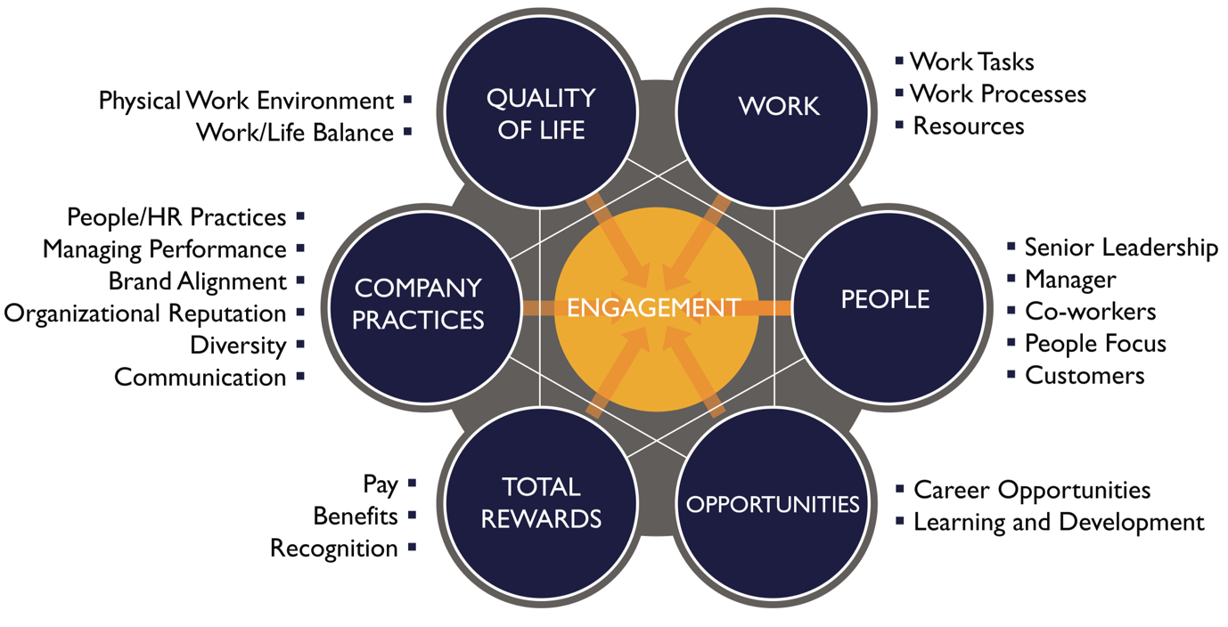

**Figure 1**. Drivers of employee engagement (adapted from Gupta & Sharma, 2016).

Having explored the factors influencing employee engagement, the subsequent inquiry revolves around how an engaged workforce can propel enhanced business performance.

In terms of organisational outcomes, work engagement is correlated with heightened customer satisfaction and loyalty, increased productivity and profitability, reduced turnover, and enhanced retention rates, coupled with improved safety measures. Moreover, improved employee engagement has been associated with positive employee outcomes, including enhanced psychological well-being and overall health.

In the context of the current project, the analysis will focus on a dataset derived from an Employee Survey at Company X. The objective is to discern potential avenues for enhancing employee engagement to leverage business performance. The analysis will be conducted separately for both quantitative and qualitative data obtained from the survey, aiming to extract actionable insights. The subsequent discussion will highlight key findings from the dataset and culminate in tailored recommendations aimed at elevating both employee engagement and business performance for Company X.

**Methods**

The research comprises two distinct sections: (1) quantitative data and (2) qualitative analysis. In the quantitative realm, an examination of questions 1 to 2_6 was undertaken. This involved employing Python tools and techniques to delve into the dataset's characteristics and explore correlations between the questions of interest.

The following tools were utilised:

1. Python Pandas: Pandas, a powerful Python library, facilitated data preparation (data cleaning) and structural manipulation. This streamlined the analysis process and eased the extraction of valuable insights from the dataset.

2. Python Matplotlib and Seaborn: These Python libraries provided the means to generate diverse visualisations, including bar, pie, and histogram charts using Matplotlib, and heatmaps via Seaborn.

3. Python NumPy and SciPy: NumPy handled basic numerical operations, calculating aggregate scores for questions 1-2_6. SciPy extended this capability, allowing for the computation of Pearson *r*-values for the correlation matrix.

In the qualitative section, the analysis focused on the ‘Q4’ column containing interview answers. Various tools and techniques were deployed:

1. Natural Language Toolkit (NLTK): NLTK, a Python library for natural language processing, aided in tasks such as removing stopwords, tokenising text, and creating frequency distributions from the interview responses.

2. Python Scikit-Learn (Sklearn): A versatile Python machine learning library that facilitated the identification of topics using Latent Dirichlet Allocation (LDA) for topic modeling.

3. Python Wordcloud: This library was employed for generating visually appealing wordclouds, offering a summarised and informative representation of the most frequent words in the text.

4. Manual Inspection: In addition to automated techniques, a manual inspection of the text was conducted to uncover common themes and topics.

These comprehensive analyses, combining both quantitative and qualitative approaches, aim to provide a thorough understanding of the dataset and extract meaningful insights for further interpretation.

**Results**

*Quantitative data – descriptive statistics and correlation matrix*

Pie charts were generated to visualise the distribution of managerial vs. non-managerial employees, and full-time vs. part-time employees.

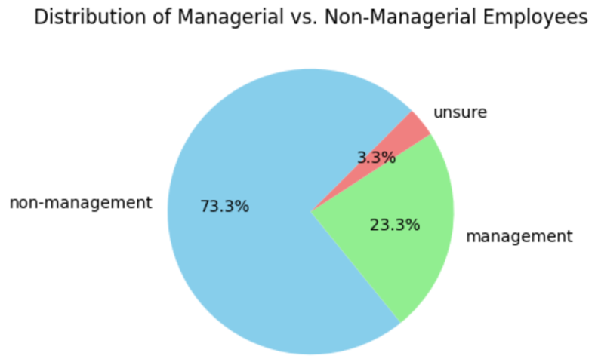

**Figure 2.** Distribution of managerial against non-managerial employees.

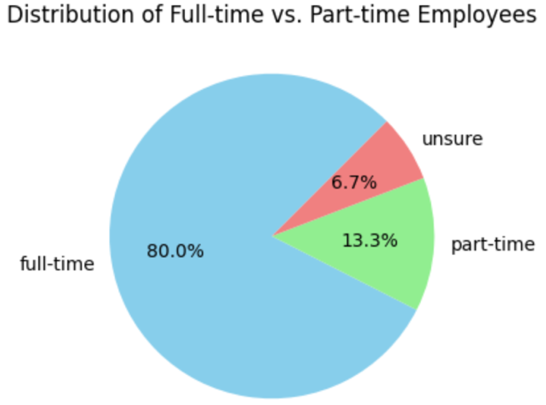

**Figure 3.** Distribution of full-time against part-time employees.

As illustrated in **Figure 2** and **3**, there are more non-managerial (73.3%) than managerial (23.3%) employees in our sample. Additionally, the current sample is made up mainly of full-time employees (80%).

As illustrated in **Figure 4**, Company X received the lowest rating for fair treatment (Q2_3), with effective policies, systems, and processes (Q2_2) and top-down communication (Q2_1) following closely. Conversely, the dimension with the highest rating is job enrichment (Q2_5), trailed by goal clarity (Q2_4) and fair pay (Q2_6).

**Figure 4.** Mean ratings for questions 1-2_6.

Concerning the outcomes of the Employee Survey, a distinct contrast emerges in the perspectives of managerial and non-managerial employees regarding the assessed organisational aspects. Notably, managerial employees consistently provide more favourable ratings across a spectrum of organisational dimensions. These dimensions include the overall rating (Q1), communication (Q2_1), policies, systems, and processes (Q2_2), employee treatment (Q2_3), goal clarity (Q2_4), job enrichment (Q2_5), and fair pay (Q2_6), as visually depicted in **Figure 5**. Interestingly, both managerial and non-managerial employees assign the highest ratings, on average, to job enrichment when compared to other dimensions. However, it is noteworthy that non-managerial employees express the lowest ratings specifically for employee treatment.

**Figure 5.** Mean ratings by management for questions 1-2_6.

Interestingly, although part-time employees, on average, assigned a lower rating to employee treatment at the company compared to their full-time counterparts, they consistently rated the company more favourably than full-time employees across all other organisational aspects. These aspects include overall rating (Q1), communication (Q2_1), policies, systems, and processes (Q2_2), goal clarity (Q2_4), job enrichment (Q2_5), and fair pay (Q2_6) as illustrated in **Figure 6**.

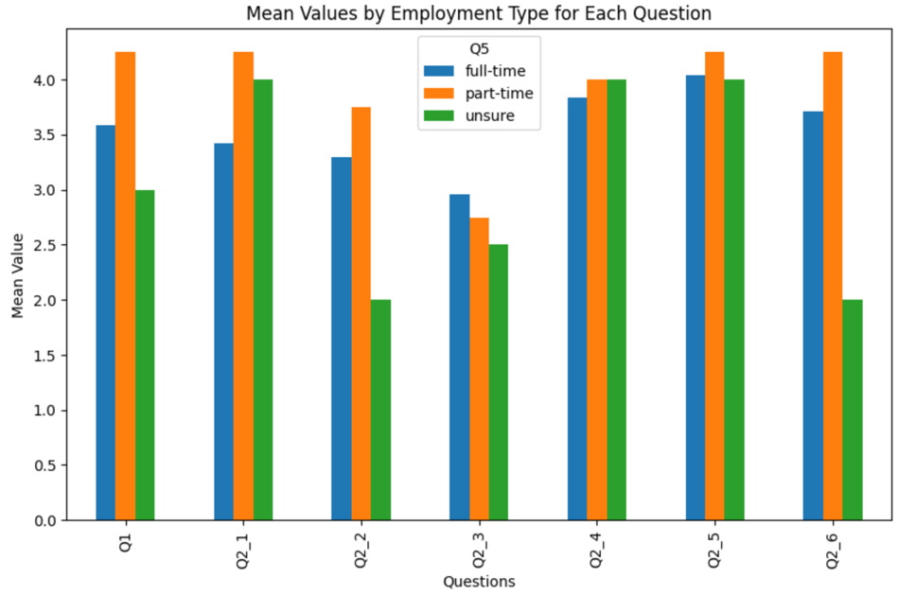

**Figure 6.** Mean ratings by employment type for questions 1-2_6.

Intriguingly, I discovered medium positive correlations between the overall rating (Q1) and the perceptions of (1) fair treatment (Q2_3) (*r*=.54), (2) goal clarity (Q2_4) (*r* =.51), (3) effective policies, systems, and processes (Q2_2) (*r* =.50), and (4) top-down communication (Q2_1) (*r* =.50). **Figure 7** visually highlights these correlations, with fair treatment showing the highest association with the overall rating, followed by effective policies, systems & processes, and top-down communication. This implies that individuals who rate the company favourably on these aspects are likely to provide an overall high rating. Notably, it suggests a distinctive emphasis on the importance of fair treatment, effective policies, systems & processes, and top-down communication within the Company X workforce. Importantly, all correlations were found to be statistically significant (*p* > .05), except for the correlation between goal clarity (Q2_2) and Q1 (*p* < .05).

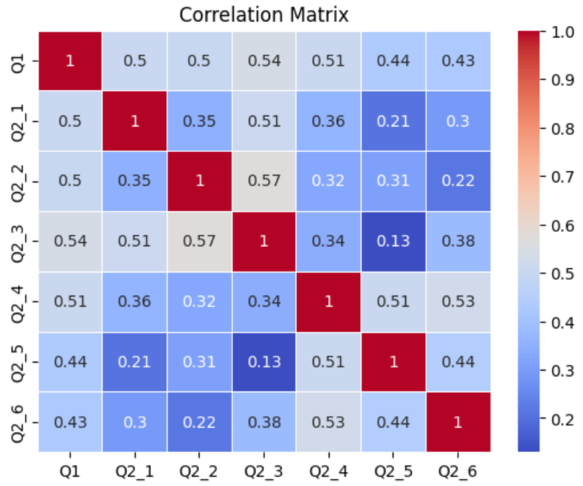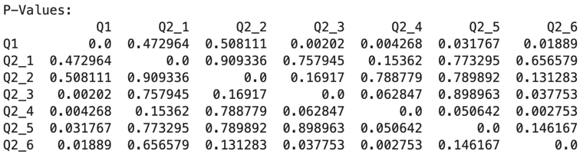

**Figure 7.** Correlational relationships between questions 1-2_6 and ccorresponding*p*-values.

**Qualitative data - worcloud and data modelling**

In this phase of the analysis, a wordcloud was generated from our qualitative data (interview answers - Q4), presenting a visual depiction where the most frequent words assume larger and more dominant positions. Essentially, this wordcloud serves as a dynamic tool to pinpoint prominent terms, enabling us to glean insights into the central themes, topics, or frequently discussed concepts embedded in the text.

A discerning examination of the wordcloud unveils the emergence of several recurrent themes (**Figure 8**). Primarily, terms like ‘staff’, ‘people’, ‘employee’, ‘retention’, ‘leaving’, and ‘turnover’ take centre stage, indicating potential issues in how the company manages its workforce. There appears to be a widespread concern about current employees leaving the company. Additionally, noteworthy terms such as ‘decision’, ‘communication’, ‘commitment’, and ‘focus’ also surface, underscoring employees' emphasis on vital aspects of organisational functioning, including decision-making, communication, commitment, and focus. To delve deeper into these themes and explore potential areas for enhancement or reinforcement within the company, a machine learning model has been developed to identify latent topics and their associated word distributions within the given corpus.

**Figure 8.** A wordcloud depicting the frequency of words from our text data.

Predictably, the machine learning model reaffirms the prevalence of themes concerning employee turnover and retention (Topic #1 and #4) (**Figure 9**). Topic #2 reveals a mix of discussions covering various workplace concerns, including topics like communication, flexibility, and morale. Notably, this aligns with the insights gleaned from our earlier wordcloud analysis. Delving deeper, Topic #3 underscores issues surrounding decision-making, emphasising staff dynamics and the imperative for targeted attention in specific areas. Finally, Topic #5 sheds light on the significance of comprehending roles, addressing challenges, overseeing projects, and prioritising employee well-being.

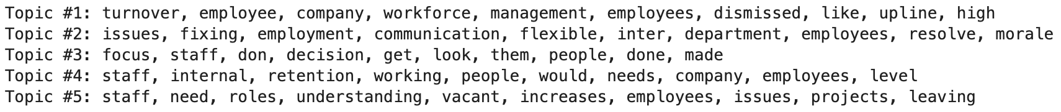

**Figure 9.** Latent topics discovered by our machine learning model.

Additionally, I also manually inspected each interview response to better understand the issues and potential solutions surrounding employee retention and other organisational functions such as communication and decision-making. The main story I get from reading over the responses is that there are ‘empty seats everywhere’ and ‘people are leaving so often’, as a result, this has put ‘pressure’ on the remaining employees. Possible solutions for employee turnover include paying ‘core staff’ well, ‘incentivise’ employees and ‘treating employees equally’. Communication and other functioning issues

**Discussion and recommendations**

Drawing insights from both the quantitative and qualitative analyses, several key observations have been identified:

* **Theme # 1:** human resource management issues, notably employee retention and fair treatment, emerged prominently in both analyses, signifying urgent concerns requiring prompt attention. Despite fair treatment receiving the lowest average rating among organisational aspects, it correlates significantly and positively with employees' overall rating of Company X. This underscores its high value among organisation members.
* **Theme# 2:** Company X faces additional challenges in organisational functioning, encompassing communication, decision-making, and targeted attention to specific areas. Notably, while communication did not emerge prominently in the quantitative analysis, the machine learning model and manual inspection revealed its significance. Furthermore, a notable divergence in perspectives between managerial and non-managerial employees highlights the importance of collaborative efforts to understand each other's viewpoints in the evaluation of organisational aspects.

Considering the identified themes and the imperative for Company X to enhance both employee engagement and business performance, the following recommendations are proposed:

1. To address theme #1, it is recommended that non-managerial and managerial employees collaborate in the redesign and implementation of a reward system. This system should prioritise the availability, durability, equity, timeliness, visibility, and performance-contingency of rewards.
2. In response to theme #2, the suggestion is to design and implement Quality Circles (QCs). These circles will serve as a mechanism to bridge the gap between managerial and non-managerial perspectives while concurrently resolving existing operational issues within the company, particularly in the realm of communication.
3. My last recommendation is to evaluate and monitor the performance of the above interventions on a 3-monthly basis to assess their interaction with the organisational context and processes.

Please see below for a detailed discussion of how and why each intervention works.

Theme 1: Employee retention and fair treatment

*Recommendation #1 – a joint effort to design and implement a reward system*

Why rewards work to improve performance

To address existing workforce dissatisfaction and improve the management and treatment of employees, I propose the design and implementation of a comprehensive reward system. This initiative signifies top management's commitment to change and responsiveness to employee concerns, particularly regarding the critical issue of employee turnover. Grounded in social exchange theory, the concept is that when employees perceive genuine care for their needs and concerns, they reciprocate with strong support for the organisation. This reciprocal relationship leads to the internalisation of organisational goals and values, prompting employees to fully engage in organisational processes (Huang & Gong, 2019).

Past research indicates that both intrinsic (e.g., enriched jobs, decision-making opportunities, pride in workmanship) and extrinsic (e.g., pay, stock options, bonuses, profit-sharing, promotions) rewards contribute significantly to team performance and satisfaction (Waddell et al., 2020). These rewards have been linked to employee motivation and positive organizational outcomes, such as reducing project delays and cost overruns (Stare, 2012) and enhancing performance in industries like cement (Qureshi et al., 2010).

Value expectancy theory posits that the ability of rewards to motivate desired behaviour depends on six factors (Waddell et al., 2020):

* Availability: systems of rewards, recognition and benefits must be clearly and coherently laid out. Employees will be de-motivated if there is any perceived inconsistency in the system (Upadhyaya, 2014).
* Timeliness: a reward loses motivational impact when there's a time gap between it and the performance it aims to reinforce.
* Performance contingency: rewards should directly align with specific performance, such that success in meeting goals warrants full rewards while falling short leads to reduced or withheld rewards. This helps increase the effectiveness of incentives in motivating desired behaviour.
* Durability: intrinsic rewards, like enhanced autonomy and a sense of pride in one's work, typically have a more enduring impact compared to extrinsic rewards.
* Equity: it is important to track the fulfilment of rewards so as not to marginalise any employee (Upadhyaya, 2014). Employee satisfaction and motivation often see improvement when there is perceived fairness or equity in the organisation's pay policies.
* Visibility: organisation members should have visibility into who is receiving rewards, as this communicates to employees that rewards are accessible, timely, and contingent on performance.

How should a reward system be designed?

I recommend the following concise actions:

1. establishing a committee (5-10 members) comprising both non-managerial and managerial employees for the collaborative design of a reward system. Employee participation in this process enhances understanding, trust, and commitment to organisational plans (Waddell et al., 2020).
2. commencing with the design and implementation of a reward system, closely monitoring its interaction with the organisational context and processes. Subsequent adjustments can be made to align the reward system more effectively with performance appraisal and goal setting, this acknowledges the integral relationship between the reward system and the broader performance management framework.
3. ensuring congruence between rewards and other organisational systems and practices, including the organisational structure, top management's human resource philosophy, and work designs.
4. ensuring that rewards exhibit characteristics of being available, durable, equitable, timely, visible, and performance-contingent. This alignment supports and reinforces organisational goals, work designs, and employee involvement.
5. ensuring a mixture of intrinsic and extrinsic rewards where applicable.

Theme 2: Communication and other operational issues => Top management must listen

*Recommendation #2 – design and implement Quality Circles or QCs (a form of participative management)*

Why Quality Circles work to improve business performance

To address operational challenges, enhance communication, and foster trust between non-managerial employees and top management at Company X, I propose implementing Quality Circles.

Participative management (PM) involves empowering and providing front-line employees with corporate decision-making authority at a non-strategic level. Research indicates that PM fulfils human needs, contributing to enhanced employee engagement, job satisfaction, productivity, and accountability (Huang & Gong, 2019; Batt & Applebaum, 1995; Johns, 2006).

Originating from Japanese manufacturing, Quality Circles (QCs) are a cost-effective form of participative management. Comprising small groups of first-line employees, QCs meet voluntarily to identify and solve organisational problems. QCs have shown positive impacts on superior-subordinate relationships (Jayakumar & Krishnaraj, 2015), work quality, teamwork, employee engagement, turnover, productivity, and job satisfaction (Samarajeewa et al., 2023; Smit et al., 2023).

How should Quality Circles be designed?

I recommend the following concise actions based on recommendations by Jayakumar & Krishnaraj (2015):

1. initiate with a single Quality Circle, assessing its performance and effectiveness one-month post-intervention before expanding the circles. Participation should be voluntary.
2. limit each QC to 5-10 members; a larger group may result in reduced meaningful contributions from individual members.
3. ideally, form cross-functional QCs, drawing members from various departments, particularly HR and IT, to address communication issues comprehensively.
4. conduct weekly 1-hour meetings, scheduling them during or after work hours based on convenience and preferences.
5. designate a QC leader responsible for facilitating meetings, setting goals, and disseminating ideas generated by members.
6. assign approximately 2-3 members to assist the leader in data gathering, record-keeping, and facilitating inter-departmental interactions.
7. organise regular meetings with top management to present findings derived from QC discussions.
8. a range of activities can be conducted during a QC meeting:

* brainstorming – for problem identification.
* pareto analysis – for priority selection. A pareto diagram visually depicts which situations/issues are more significant. Problems with higher frequencies should be prioritised for resolution. An example is shown in **Figure 10**.

**Figure 10.** An example pareto diagram depicting the frequency of different types of customer complaints.

* cause-effect analysis – for cause identification and potential solutions. Members can begin by identifying the primary organisational issue and then hierarchically trace its root cause backward. An example of a cause-effect diagram is provided below.

**Figure 11.** An example of a cause-effect diagram.

1. many areas could be tackled by a Quality Circle, for example, better customer service or systems development. But in essence, members should adhere to the following rules:

* no criticism
* encourage free-wheeling
* record all ideas
* equal opportunity to involved members

1. openly reward or compliment any commendable proposal or achievement. Recognition serves as a powerful motivator for sustaining and enhancing the performance of the QC (Majumdar & Manohar, 2011).

Causes for failure:

* trade union opposition;
* resistance from middle management, which sprouted from a fear of losing control and authority;
* senior management’s insistence that minutes needed to be taken at every meeting, which employees interpreted as a sign of distrust

*Recommendation #3 – evaluation and monitoring*

**Reference**

Kaufman, B. E. (2001). The theory and practice of strategic HRM and participative management: Antecedents in early industrial relations. Human Resource Management Review, 11(4), 505–533. <https://doi.org/10.1016/S1053-4822(01)00051-1>

Smit, I., Bam, L., & Zincume, P. N. (2023). PARTICIPATIVE MANAGEMENT FOR TEAM EFFECTIVENESS AND INNOVATION. South African Journal of Industrial Engineering, 34(1), 28–41. <https://doi.org/10.7166/34-1-276>

Huang, C.-S., & Gong, D.-C. (2019). How Participation Management Influences Work Engagement: The Mediating Role of Perceived Fit and Leader-Member Exchange. International Journal of Business and Management, 14(12), 191-. <https://doi.org/10.5539/ijbm.v14n12p191>

Dulebohn, J. H., Bommer, W. H., Liden, R. C., Brouer, R. L., & Ferris, G. R. (2012). A meta-analysis of antecedents and consequences of leader-member exchange integrating the past with an eye toward the future. Journal of Management, 38, 1715-1759. <https://doi.org/10.1177/0149206311415280>

Prakas Majumdar, J., & Murali Manohar, B. (2011). How to make Quality Circle a success in manufacturing industries. Asian Journal on Quality, 12(3), 244–253. <https://doi.org/10.1108/15982681111187083>

Gupta, N., & Sharma, V. (2016). Exploring Employee Engagement—A Way to Better Business Performance. Global Business Review, 17(3_suppl), 45S-63S. <https://doi.org/10.1177/0972150916631082>

Harter, J.K., Schmidt, F.L., & Hayes, T.L. (2002). Business-unit-level relationship between employee satisfaction, employee engagement and business outcomes: A meta-analysis. Journal of Applied Psychology, 87(2), 268–279.

Rich, B.L., Lepine, J.A., & Crawford, E.R. (2010). Job engagement: Antecedents and effects on job performance. Academy of Management Journal, 53(3), 617–635.

Shuck, B., & Wollard, K. (2010). Employee engagement and HRD: A seminal review of the foundations. Human Resource Development Review, 9(1), 89–110.

Gulyani, G., & Sharma, T. (2018). Total rewards components and work happiness in new ventures: The mediating role of work engagement. Evidence-Based HRM : A Global Forum for Empirical Scholarship, 6(3), 255–271. <https://doi.org/10.1108/EBHRM-12-2017-0063>

Scott, W. E., Farh, J.-L., & Podsakoff, P. M. (1988). The effects of “intrinsic” and “extrinsic” reinforcement contingencies on task behavior. Organizational Behavior and Human Decision Processes, 41(3), 405–425. <https://doi.org/10.1016/0749-5978(88)90037-4>

Stare, A. (2012). The impact of a project organisational culture and team rewarding on project performance. Journal of East European Management Studies, 17(1), 40–67. <http://www.jstor.org/stable/23281743>

Qureshi, M. I., Zaman, K., & Shah, I. A. (2010). Relationship between rewards and employee’s performance in the cement industry in Pakistan. Journal of international academic research, 10(2), 19-29.

Upadhyaya, C. (2014). Application of the Maslow’s hierarchy of need theory; impacts and implications on organizational culture, human resource and employee’s performance. International Journal of Education and Management Studies, 4(4), 353-.

Lawler, E. E., Jenkins, G. D., & Cardoze, S. D. (1976). Employee participation in pay plan development. Institute for Social Research, University of Michigan.

Rohrbasser, A., Harris, J., Mickan, S., Tal, K., & Wong, G. (2018). Quality circles for quality improvement in primary health care: Their origins, spread, effectiveness and lacunae- A scoping review. PloS One, 13(12), e0202616–e0202616. <https://doi.org/10.1371/journal.pone.0202616>

Anand Jayakumar, A., & Krishnaraj, C. (2015). Quality circle–Formation and implementation. International Journal of Emerging Researches in Engineering Science andTechnology, 2(2).

Ellis, G., Found, P., Kumar, M., & Harwell, J. (2019). New evidence on the origins of quality circles. Total Quality Management & Business Excellence, 30(sup1), S129–S140. <https://doi.org/10.1080/14783363.2019.1665830>

Abbott, Martin L. (1987) "Looking Closely at Quality Circles: Implications for Intervention," Clinical Sociology Review: Vol. 5: Iss. 1, Article 12.

Available at: <https://digitalcommons.wayne.edu/csr/vol5/iss1/12>

Batt, R. & Applebaum, E. (1995). Worker Participation in Diverse Settings: Does the Form Affect the Outcome, and if so, who Benefits? British Journal of Industry Relations, 33(3), 353-378. <http://dx.doi.org/10.1111/j.1467-8543.1995.tb00444.x>

Johns, G. (2006). The essential impact of context on organizational behavior. Academy of Management Review, 31(2), 386-408. <https://doi.org/10.5465/amr.2006.20208687>

Samarajeewa, C. T., Rajaratnam, D., Disaratna, P. A. P. V. D. S., Perera, B. A. K. S., & Wijewickrama, M. K. C. S. (2023). Quality Circles: An Approach to Determine the Job Satisfaction of Construction Employees. International Journal of Construction Education and Research, 19(1), 61–76. <https://doi.org/10.1080/15578771.2021.1950243>

Smit, I., Bam, L., & Zincume, P. N. (2023). PARTICIPATIVE MANAGEMENT FOR TEAM EFFECTIVENESS AND INNOVATION. South African Journal of Industrial Engineering, 34(1), 28–41. <https://doi.org/10.7166/34-1-2767>